|  |
| --- |
| **North South University**  Department of Electrical & Computer Engineering  **LAB REPORT-7**  Course Code: CSE231L  Course Title: Digital Logic Design  Section: 8  Experiment Number: 7  Experiment Name:  Introduction to Flip-Flops and Shift Registers  Experiment Date: 14/8/2021  Date of Submission: 22/8/2021  Submitted By: Md. Rifat Ahmed - 1931725042  Course Instructor: Md. Shahriar Hussain  Submitted To: Md. Anisur Rahman Asif |

**Objectives:**

* Our first objective is to learn about the concept of states in digital logic and how Flip-Flop circuits can be used to store state information.
* Then we need to understand the internal logic of J-K Flip-Flops and implement one using basic logic gates.
* Then we have to understand the relationship between J-K, T and D Flip-Flops and observe the characteristics of all three.
* And finally, we have to implement a shift register using D Flip-Flops and analyze its operation.

**Apparatus:**

**Experiment 1:**

* 1 x IC 7402 2-input NOR gates
* 1 x IC 7411 3-input AND gates
* Trainer Board
* Wires

**Experiment 2:**

* 1 x IC 7402 2-input NOR gates
* 1 x IC 7411 3-input AND gates
* 1 x IC 7404 Hex Inverter (NOT gates)
* Trainer Board
* Wires

**Experiment 3:**

* 2 x IC 7474 (D Flip-Flop)
* Trainer Board
* Wires

**Theory:**

**Flip-Flops:**

There are two types of digital logic circuits. We are already familiar first one which is combinational circuits and the second one is sequential circuits. Now sequential circuits are a bit different while combinational circuits depend only on the current inputs sequential circuits depend on both current and past inputs. Now to store the information of the past inputs we need electronic memory devices and that’s what Flip-Flops and latches are.

A flip-flop is a binary storage device which can store only one bit of information either 0 or 1.

**Registers:**

Registers are nothing but a group of flip-flops. So, while a flip-flop can store only up to 1 bit of information a register made up of ‘n’ number of flip-flops can store information up to ‘n’-bit. And a register which can shift its binary information left or right is called a shift register where all the flip-flops are connected to a common clock which causes the shift from one step to the next one.

**Experimental Procedure:**

**Experiment 1:**

At first, we have to construct the JK flip-flop shown in Figure 1. Then we have to complete the truth table after setting the values for J and K, then send a clock pulse and observe the output and then for the different combinations we have send several clock pulses and complete Table 1.

**Experiment 2:**

To start this experiment, we’ll take the circuit of the JK flip-flop we previously built for experiment 1. Then we’ll connect both the inputs into the same switch then the circuit will behave like a T flip-flop. Then for both the input values of T flip-flop we have to send several clock pulses for each input, observe their output and then complete Table 2.1.

And then we’ll take the same circuit as experiment 1 again but this time we’ll send the inverse of the 1st input into the 2nd one this way the JK flip-flop will be converted into a D flip-flop. Now, just like we did with the JK converted T flip-flop we’ll send several clock pulses for each of the input of the D flip-flop observe their output and complete Table 2.2.

**Experiment 3:**

Finally, for the last experiment, we have to construct a right shift register using Figure 3. Then we can build the circuit using two 7474 ICs because each of them contains two D flip-flops. Then we have to connect the output of each of the four flip-flops into four different LEDs so that we can check the output of each flip-flop after every clock pulse. Now to check how the circuit is working we’ll set the input to 1 and send a clock pulse then set the input to 0 and send several more clock pulses and then again set input to 1 and send clock pulses until all the LEDs are lit. Then again with input as 0 we send clock pulses until all the LEDs are off this time. Then we have to complete Table 3 for a combination where the clock pulses will create ON-OFF-ON-OFF sequence in the four outputs.

**Question/Answer:**

**Answer to the Question No. 1 of Experiment 2:**

Both T and D flip-flops take only one input and can store only one bit information either 0 or 1.

However, in a T flip-flop when the input is 0 the output doesn’t change and remains the same as before but when the input is 1 every time a clock pulse is given it toggles its output between 0 and 1. And a T flip-flop can be implemented using a JK flip-flop if we just connect both the 1st and the 2nd input into the same switch.

On the other hand, in a D flip-flop for 0 as input it’ll always give the output 0 and for 1 as input it’ll give the output 1. So, the D flip-flop always has the same input and output. And a D flip-flop can also be implemented using a JK flip flop just by giving the inverse of the 1st input into the 2nd one.

**Answer to the Question No. 1 of Experiment 3:**

Shift registers are sequential logic circuits that’s used for storing multiple bit binary information. They use a cascade of flip-flops to store data where the output of one flip-flop is connected to the input of the next flip-flop and they also share the same clock so they’re able to shift the data from one flip-flop to another. So, for circuits where we need to shift data by one bit either to left or right, we need shift registers.

**Answer to the Question No. 2 of Experiment 3:**

If the output of the last D Flip-Flop in the register was connected to the input of the first D Flip-Flop, then the circuit will work like a counter where the outputs will keep rotating with every clock pulse.

**Discussion:**

Through this lab we have learned some new topics such as sequential circuits, flip-flops and registers. Sequential circuits depend on both past and present inputs and to store the past outputs we need memory devices like flip-flops and a group of these memory devices are registers. So, in the first experiment we had to build a JK flip-flop and then find the outputs for different values of J and K. Then in the 2nd experiment we converted the previously build JK flip-flop into a T and D flip-flops then we saw how these two flip-flops differ from each other despite of having only one input. Then in the 3rd and final experiment we had to build a right shift register using D flip-flops. We built the circuit the observed how it behaves according to different inputs then found a combination of inputs to produce an ON-OFF-ON-OFF sequence in their output and this marking the end of our lab 7. In this lab we had to do 3 different experiments and at the 1st experiment we were struggling a bit but the 2nd and 3rd experiments went on smoothly.

**Data Sheet & Circuit Diagrams:**

**Data of Experiment 1: J-K Flip-Flop using AND and NOR gates**

|  |  |  |  |
| --- | --- | --- | --- |
| **J** | **K** | **Qnext** | **Q’** |
| 1 | 0 | 1 | 0 |
| 0 | 0 | 1 | 0 |
| 0 | 1 | 0 | 1 |
| 0 | 0 | 0 | 1 |
| 1 | 1 | 1 | 0 |
| 1 | 0 | 1 | 0 |
| 1 | 0 | 1 | 0 |
| 1 | 1 | 0 | 1 |

**Table 1**

**Data of Experiment 2: T and D Flip-Flops using J-K Flip-Flops**

|  |  |
| --- | --- |
| **T** | **Q** |
| 0 | **Q** |
| 1 | **Q’** |

|  |  |
| --- | --- |
| **D** | **Q** |
| 0 | **0** |
| 1 | **1** |

**Table 2.1 Table 2.2**

**Data of Experiment 3: Right shift register using D Flip-Flops**

|  |  |  |
| --- | --- | --- |
| **States** | **Input** | **Output** |
| Initial State | X | XXXX |
| T1 | 1 | 1XXX |
| T2 | 0 | 01XX |
| T3 | 1 | 101X |
| T4 | 0 | 0101 |

**Table 3**

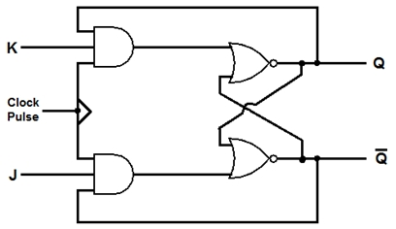

**Figure 1:** JK Flip-Flop implemented using AND and NOR gates

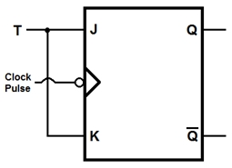

**Figure 2.1:** T flip-flop constructed using JK flip-flop

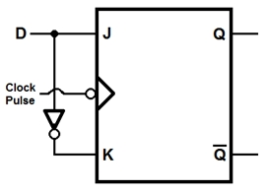

**Figure 2.2:** D flip-flop constructed using JK flip-flop

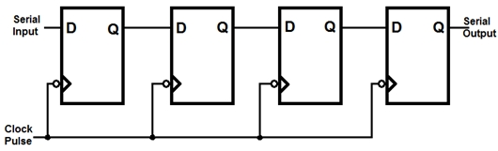

**Figure 3:** Right Shift Register

**Simulation:**

Simulating Experiment 3:

